NextJS – Client and Server Interaction

* All practical work is done in 23. Next Js – Wild oasis website

# Client Component in a Server Component

* /cabins/id page
* We want to add interactivity on the /cabins/id page, so that the user can expand the text
* For this, we need to move the code from /cabins/id page to the **client as a CLIENT COMPONENT 🡺 TextExpander client component**
* We will place the new CLIENT COMPONENT inside the /cabins/id server component
* A client component can Use a Server component, as long as the server component has been imported in a parent server component before

# Highlight Current Link in the Side Navigation in Guest Area

* We use a **React HOOK**
  + usePathName() => takes the pathname of the URL
* But the Hook work only in **client components**
  + **Use client** to transform the component to a **client Component**

# Sharing state and data between Client and Server

* Building the filter in the Cabins page
* We will **store the state in the URL**
  + We will use **searchParams** to read/write the data from the **URL**
* 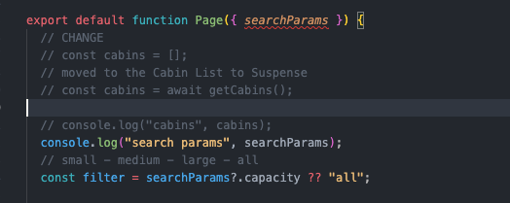
* We pass it to the **Server Component**  as a prop

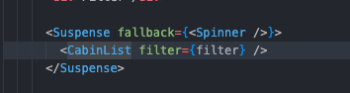

* We filter the cabins based on this filter

## Update the URL with the new filter

* We use the web api – **URLSearchParams()**
  + New URLSearchParams( newParams )
* Combined with **useSearchParams**()
  + Const newParams = useSearchParams()
* Combined with **usePathName()**
  + const pathname = usePathName();
* Now we can set the newParams to whatever we want, like a local storage key
  + newParams.set(‘capacity’, filter value)
* we use the **replace** function from **next/navigation useRouter()**
  + **replace(`${pathname}?${newParams.toString()}`);**



# Server Components into Client Components

* Check the Select Country dropdown from the Guest Profile page